
LESSON NOTE | DETAILED EXPLANATORY NOTES
NEUROSCIENCE & AI
BEHAVIOURAL & MOTIVATIONAL MECHANISMS (LIMBIC SYSTEM)
GRADE 12 - BIOLOGY
■ ■ ■

The Emotional Brain
Not everything the brain does is cool reasoning. Much of our behaviour is driven by emotions, drives and motivations - fear, hunger, pleasure, anger and the urge to survive. These come from a group of structures deep in the brain called the limbic system. Sitting between the thinking cortex above and the brain stem below, the limbic system links emotion, motivation and memory, and it strongly shapes how we behave.
This lesson describes the main structures of the limbic system, the functions they control, and how they produce emotional and motivated behaviour. It builds on earlier lessons about the cortex, learning and memory, showing the more instinctive, feeling side of the brain.
Why This Matters
- The limbic system drives emotion and motivation.
- It controls basic drives - hunger, thirst, temperature, sex and survival.
- It links emotion to memory, making emotional events memorable.
- It helps explain behaviour, stress and mental health.
Behavioural & Motivational Mechanisms (Limbic System)
Key Learning Outcomes
By the end of this lesson, students should be able to:
- Identify the main structures of the limbic system and their roles.
- Explain how the limbic system controls emotion and basic drives.
- Explain what motivation is and how reward shapes behaviour.
- Trace how the limbic system produces an emotional/behavioural response.
- Relate the limbic system to stress, learning and wellbeing.
Structures of the Limbic System
The limbic system is a set of connected structures deep in the brain. The amygdala is the centre for emotions, especially fear and anger, and rapidly judges whether something is a threat. The hippocampus forms new long-term memories and links them to places and feelings. The hypothalamus controls basic drives - hunger, thirst, body temperature - and switches on the body's fight-or-flight response through hormones and the autonomic system. The thalamus acts as a relay station, passing sensory information on to the rest of the brain.
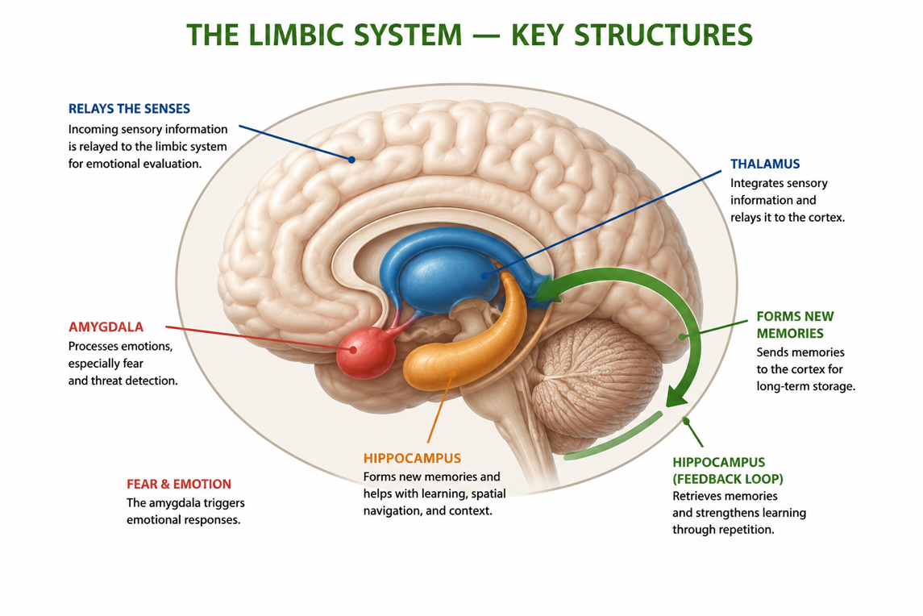
Figure 1: Key structures of the limbic system - amygdala, hippocampus, hypothalamus and thalamus.
Terminologies and Concepts
Useful terms for this topic:
- Limbic system: the brain structures controlling emotion, motivation and memory.
- Amygdala: the emotion centre, especially for fear and anger.
- Hippocampus: forms new long-term memories.
- Hypothalamus: controls drives (hunger, thirst, temperature) and hormones.
- Motivation: the internal drive that directs behaviour towards a goal.
- Reward: a pleasant feeling that encourages a behaviour to be repeated.
- Fight-or-flight: the body's rapid response to a threat.
Functions - Emotion, Drives and Motivation
The limbic system carries out several linked jobs. It generates emotions such as fear, pleasure and anger. It controls basic drives - the urges to eat, drink and stay at the right temperature - that keep the body alive. It creates motivation, the internal push to act, often through a reward system: behaviours that bring pleasure (eating when hungry, succeeding at a task) are reinforced and repeated. And it links emotion with memory, which is why strongly emotional events - frightening or joyful - are remembered so vividly.
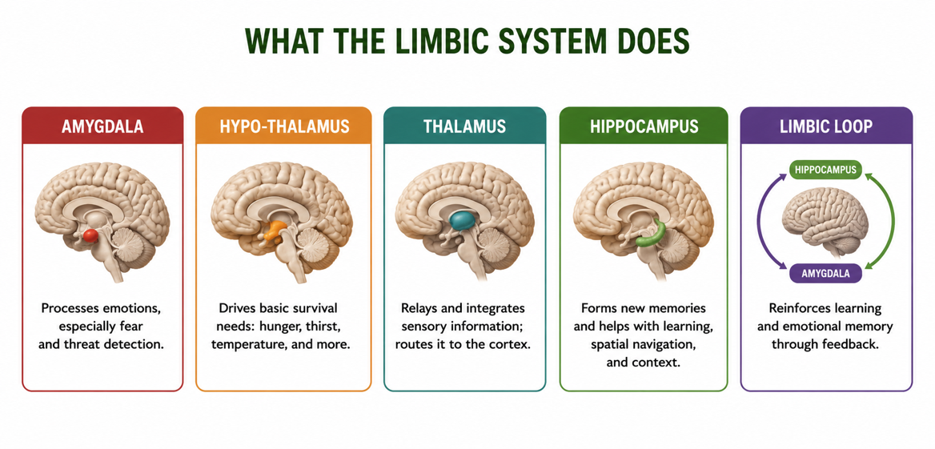
Figure 2: The main functions of the limbic system - emotion, motivation, drives, memory and behaviour.
How Emotion Produces Behaviour
When something happens, sensory information reaches the amygdala, which quickly judges its emotional meaning - for example, recognising a threat and producing fear. The amygdala alerts the hypothalamus, which triggers the body's response: raising heart rate, releasing adrenaline, and preparing the muscles. The result is a fast behaviour - fight, flight or freeze - that can happen before we have consciously thought about it. This is why we may jump back from a snake before we even realise what we saw. Emotion thus drives motivation and behaviour, often ahead of conscious reasoning.
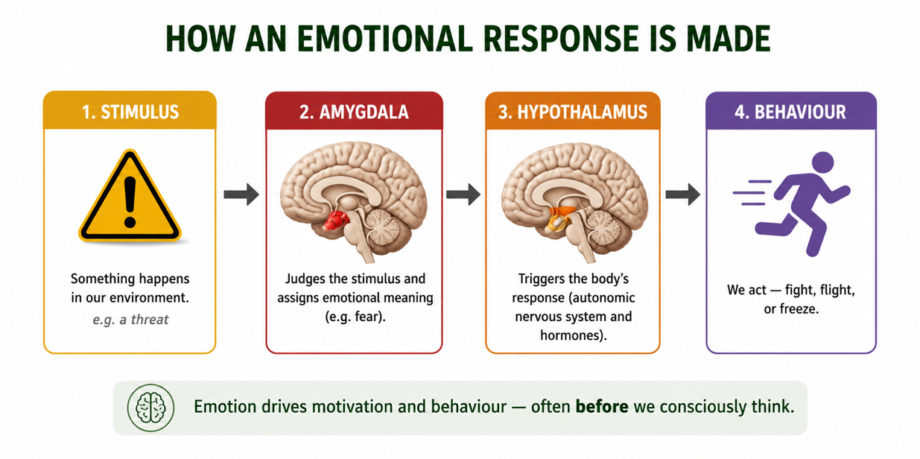
Figure 3: An emotional response - the amygdala judges a threat and the hypothalamus drives the behaviour.
Emotion, Memory and Motivation Together
The limbic structures work as a team. The amygdala's emotional 'tag' makes the hippocampus store an event more strongly, so we remember what frightened or delighted us. The hypothalamus links our drives to those memories and to the reward system, motivating us to seek what felt good and avoid what felt bad. This teamwork of emotion, memory and motivation guides learning and behaviour — it is why we are motivated to repeat rewarding actions and cautious about ones linked to fear or pain.
Why This Matters
- Behaviour - the limbic system explains much of what motivates our actions.
- Survival - drives and fight-or-flight keep us alive and safe.
- Learning - emotion strengthens memory and motivation to learn.
- Mental health - it helps explain stress, anxiety and addiction.
PNG Context Example
Understanding the limbic system is valuable for wellbeing in Papua New Guinea. The fight-or-flight response is helpful in real danger but, if triggered constantly by ongoing stress, can harm health — a useful idea for understanding stress and anxiety in daily life. The reward system helps explain why habits, including harmful ones such as betel nut, alcohol or tobacco use, can be hard to break, since they act on the brain's reward pathways. Knowing that emotion strengthens memory also encourages positive, engaging learning. These insights support health, counselling and education in PNG communities.
References & Related Documents
Source Documents
- STEM Biology Syllabus - Grade 12. Thema: Neurophysiology; Module: Behavioural and Motivational Mechanisms (Limbic System). Department of Education, PNG.
- Biology Standards-Based Syllabus, Grades 11 & 12 (PNG SBC 2020) - Strand 2: Life; investigate how the brain controls behaviour, emotion and homeostatic drives.
Further Reading & References
- OpenStax Biology - The Brain; The Limbic System and Emotion. https://openstax.org/books/biology
- Khan Academy - Emotion, motivation, and the limbic system. https://www.khanacademy.org/science/biology/human-biology

